Answers
Task 1 Barcodes and QR codes
(a) Use an online barcode generator (such as www.barcode-generator.org) to create a UPC-A barcode for the product code number:
3 9 4 6 6 1 2 9 9 4
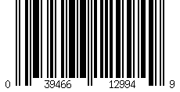
(b) Describe how the barcode could be used to track a package that is sent from a UK business to a customer in the USA.
The company in the UK will print a label with the barcode on.
This will be scanned at the post office / drop off location.
The code will be linked in a database to all the delivery details.
Each time the package goes to a depot / plane / truck, it will be scanned to see where the destination is.
When the package arrives at the final destination, the person delivering it will scan the package and mark the item as delivered.
The database is therefore able to keep up to date information of where the package is located.
(c) Use an online QR code generator (such as www.barcode-generator.org) to create a series of three codes for a local restaurant business. You must include:
(i) A website address.
(ii) A vCard used for saving contact information directly to a computer or phone.
(iii) Some text information about a special offer.
Examples:
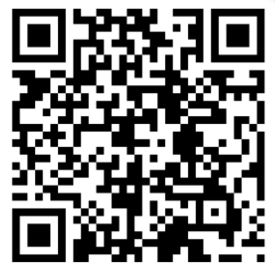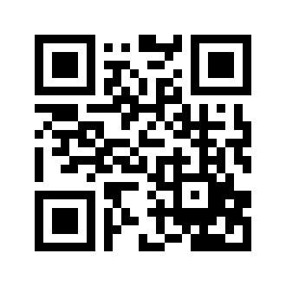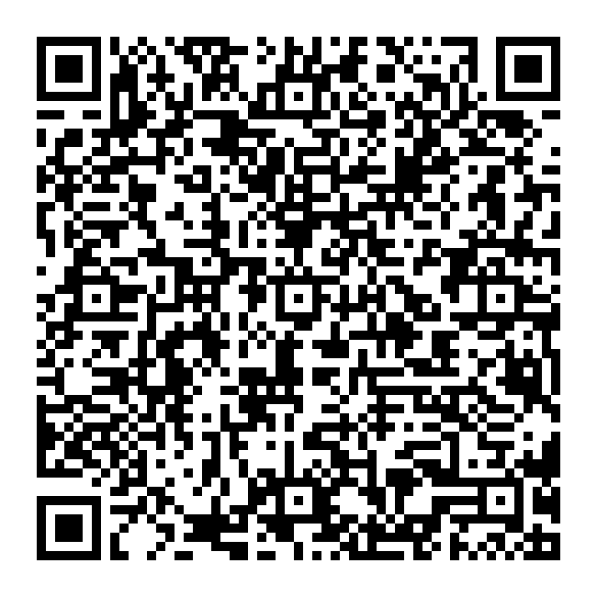
(d) If you have a mobile phone with a scanner, test to see that your QR codes work and ask a friend to also test them.

Task 2 Scanners and cameras
(a) Traditional photocopiers work by scanning a light beam across a page to be copied. If 50 copies are needed, the beam needs to scan the page 50 times.
What are the advantages of using a digital scanner as part of the photocopier?
The page will be scanned once. After this, each copy is printed from the digital scan that was saved.
By having a digital scan, it is also possible for the photocopier to save a digital file such as a PDF.
(b) Digital cameras are commonly used in modern society.
Discuss with a partner where digital cameras are used and list as many possible uses as possible below.
Some examples include:
- Professional photographers
- General photography/camera phones
- CCTV, including security
- Doorbells – for security and to see when packages arrive / who is visiting a property
- Video conferencing
- Checking product quality in factories
- Recording video of activities, e.g., GoPro
- Drone cameras
- Police and security body cameras
(c) 3D scanners are currently used in many industries.
Research three different uses for 3D scanners and make notes on your findings below.
Answers will depend on student’s research.
Areas where 3D scanners are used include:
- Medicine, including body scans and scans of teeth in dentistry
- Archaeology, scanning historical artefacts for research and to allow access to 3D models for the public
- Virtual reality (VR) and visual effects (VFX) in games and cinema
- Forensics – to help reconstruct crime scenes
- Manufacture – quality control of parts
- Dentistry – making teeth 3D models

Optional Task 3 Reading barcodes
The specification expects students to understand what is meant by a barcode and why it is required. This task most likely goes beyond these requirements. However, students should find it an interesting extension task that explains how barcodes work. As such, it is included as an optional task here.
Barcode readers or scanners are used to read barcodes on supermarket products, books and other products and, for example, for tracking packages during shipping.
The Code-128 system can represent all alphanumeric characters. The UPC-A barcode below contains guard bars and represents numeric values only.
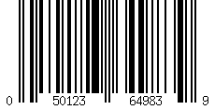
0
1
2
3
4
5
6
7
8
9
Left Right
(a) The grid below represents the left-hand side of a standard UPC-A barcode.
Shade in the bars according to the code patterns in the left side of the chart above.
Left  Guard |  |  | 0 (Start) |  |  |  |  |  |  | 5 |  |  |  |  |  |  | 9 |  |  |  |  |  |  | 2 |  |  |  |  |  |  | 7 |  |  |  |  |  |  | 3 |  |  |  |  |  |  | Middle Guard
(b) Now think of a six-digit number that you want to encode in the barcode below.
Encode the bar code, then show it to a partner and see if they can correctly decode the number that you thought of.
Left  Guard |  |  | ? (Start) |  |  |  |  |  |  | ? |  |  |  |  |  |  | ? |  |  |  |  |  |  | ? |  |  |  |  |  |  | ? |  |  |  |  |  |  | ? |  |  |  |  |  |  | Middle Guard

